Sidereal Year
# Source: AI Source: Provided by: [Data Path: Persons Table -> ID Column: 1, Name_En Column: Motasem Essam] -> From: [ChatGPT] on [7/17/2026]
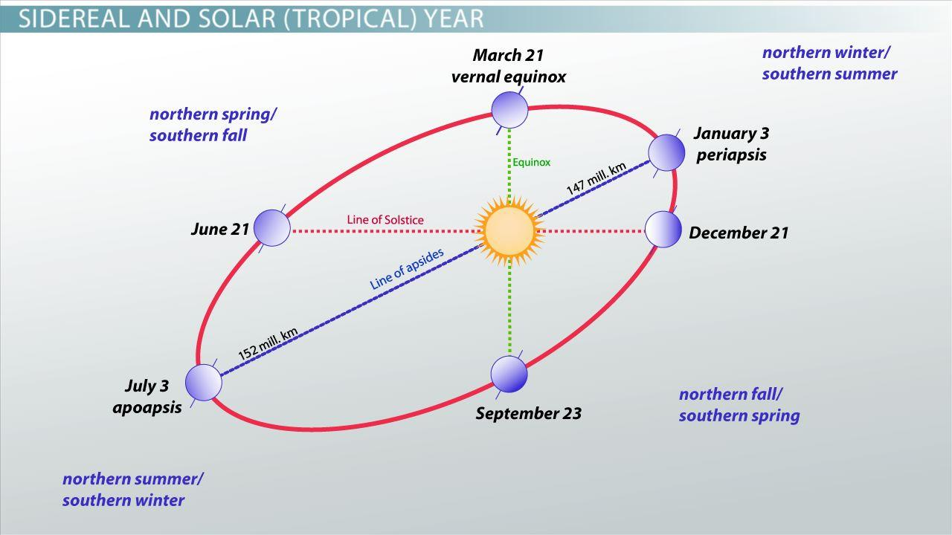
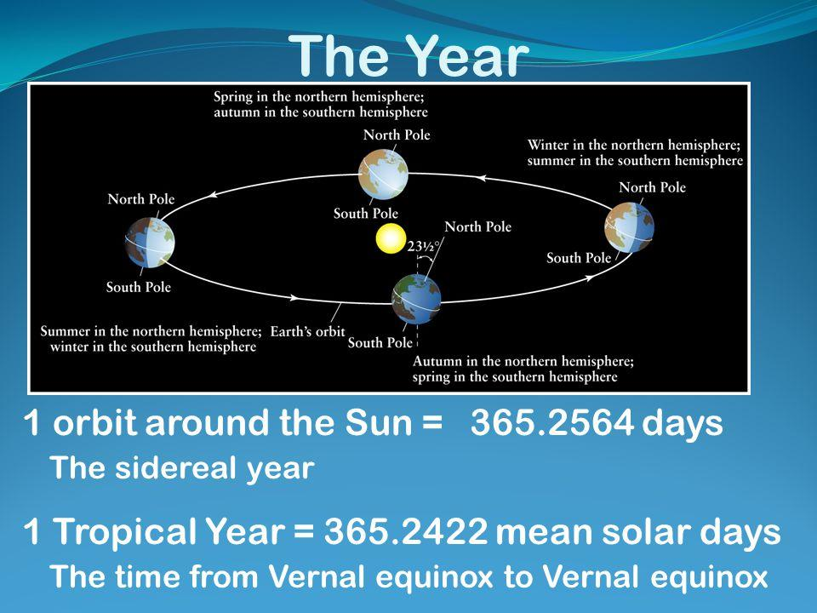
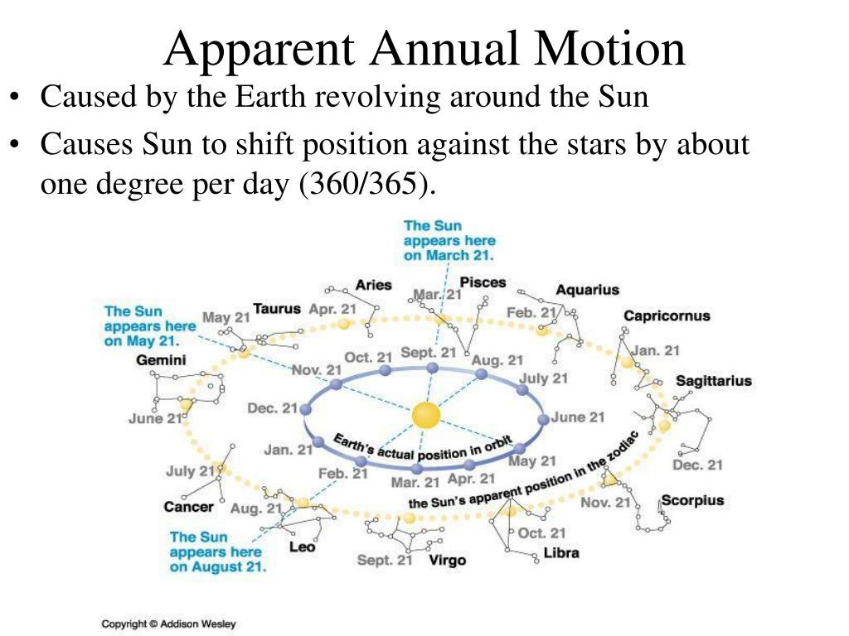
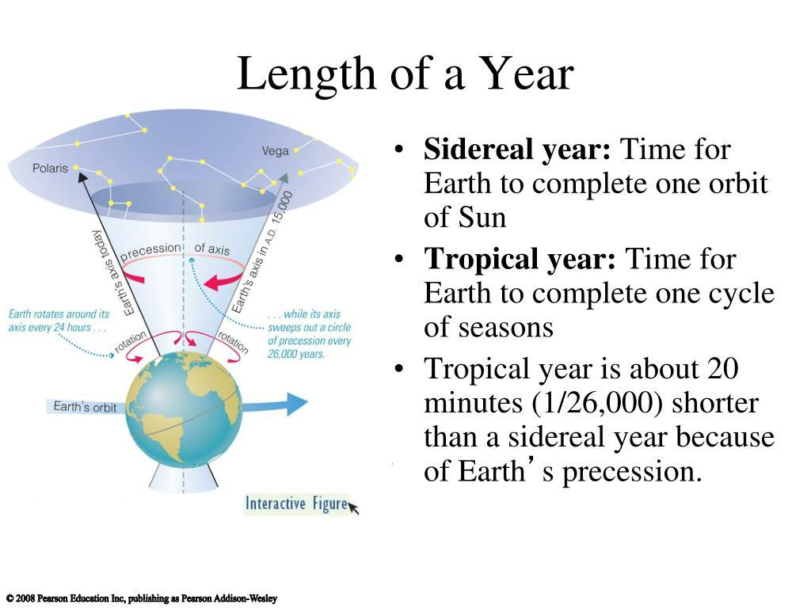
A Sidereal Year is the time required for the Earth to complete one full revolution around the Sun relative to the distant stars. Unlike the Tropical Year, which is measured relative to the seasons (equinoxes), the sidereal year is measured relative to the fixed background of distant stars.
The average length of a sidereal year is approximately:
$$365.2564\text{ days}$$
Because the Earth's rotational axis slowly changes direction over time (a phenomenon called axial precession), the sidereal year is slightly longer than the tropical year.

Definition
# Source: AI Source: Provided by: [Data Path: Persons Table -> ID Column: 1, Name_En Column: Motasem Essam] -> From: [ChatGPT] on [7/17/2026]
A Sidereal Year is the time required for the Earth to complete one orbit around the Sun relative to the distant stars.

Astronomical Basis
# Source: AI Source: Provided by: [Data Path: Persons Table -> ID Column: 1, Name_En Column: Motasem Essam] -> From: [ChatGPT] on [7/17/2026]
A sidereal year measures the Earth's orbit using a fixed reference point among distant stars.
For example:
- Earth begins at a particular position relative to a distant star.
- After one complete orbit, it returns to the same position relative to that star.
Because the stars are extremely distant, they provide an almost fixed reference frame.

Average Length
# Source: AI Source: Provided by: [Data Path: Persons Table -> ID Column: 1, Name_En Column: Motasem Essam] -> From: [ChatGPT] on [7/17/2026]
Average Length

The average length of a sidereal year is:

365.2564 days

Equivalent to approximately:

365 days
6 hours
9 minutes
10 seconds

Why Is It Longer Than the Tropical Year?
# Source: AI Source: Provided by: [Data Path: Persons Table -> ID Column: 1, Name_En Column: Motasem Essam] -> From: [ChatGPT] on [7/17/2026]
The Sidereal Year is about 20 minutes longer than the Tropical Year.
Average lengths:
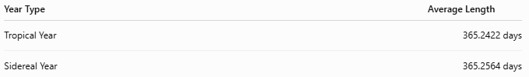
Year Type | Average Length
Tropical Year | 365.2422 days
Sidereal Year | 365.2564 days
Difference:
$$365.2564-365.2422=0.0142\text{ days}$$
Approximately:
- 20 minutes 24 seconds
This difference exists because the Earth's axis slowly precesses, causing the equinoxes to shift slightly westward along the Earth's orbit each year. As a result:
- The Earth reaches the next spring equinox slightly before it reaches the exact same position relative to the distant stars.

Axial Precession
# Source: AI Source: Provided by: [Data Path: Persons Table -> ID Column: 1, Name_En Column: Motasem Essam] -> From: [ChatGPT] on [7/17/2026]
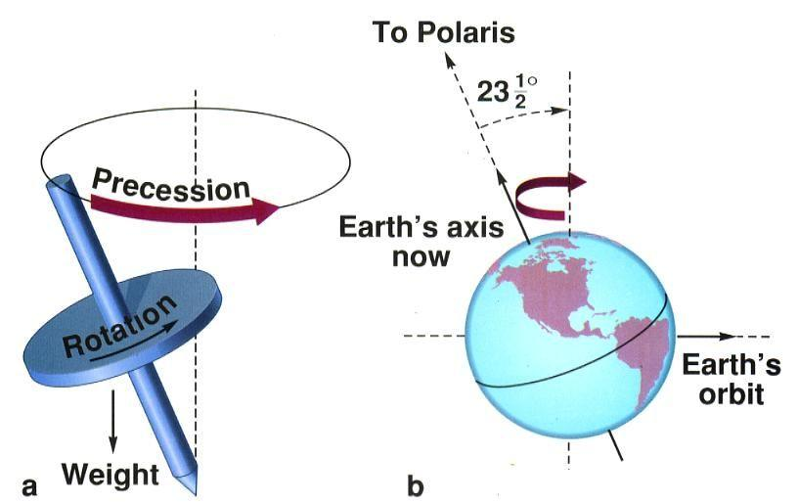
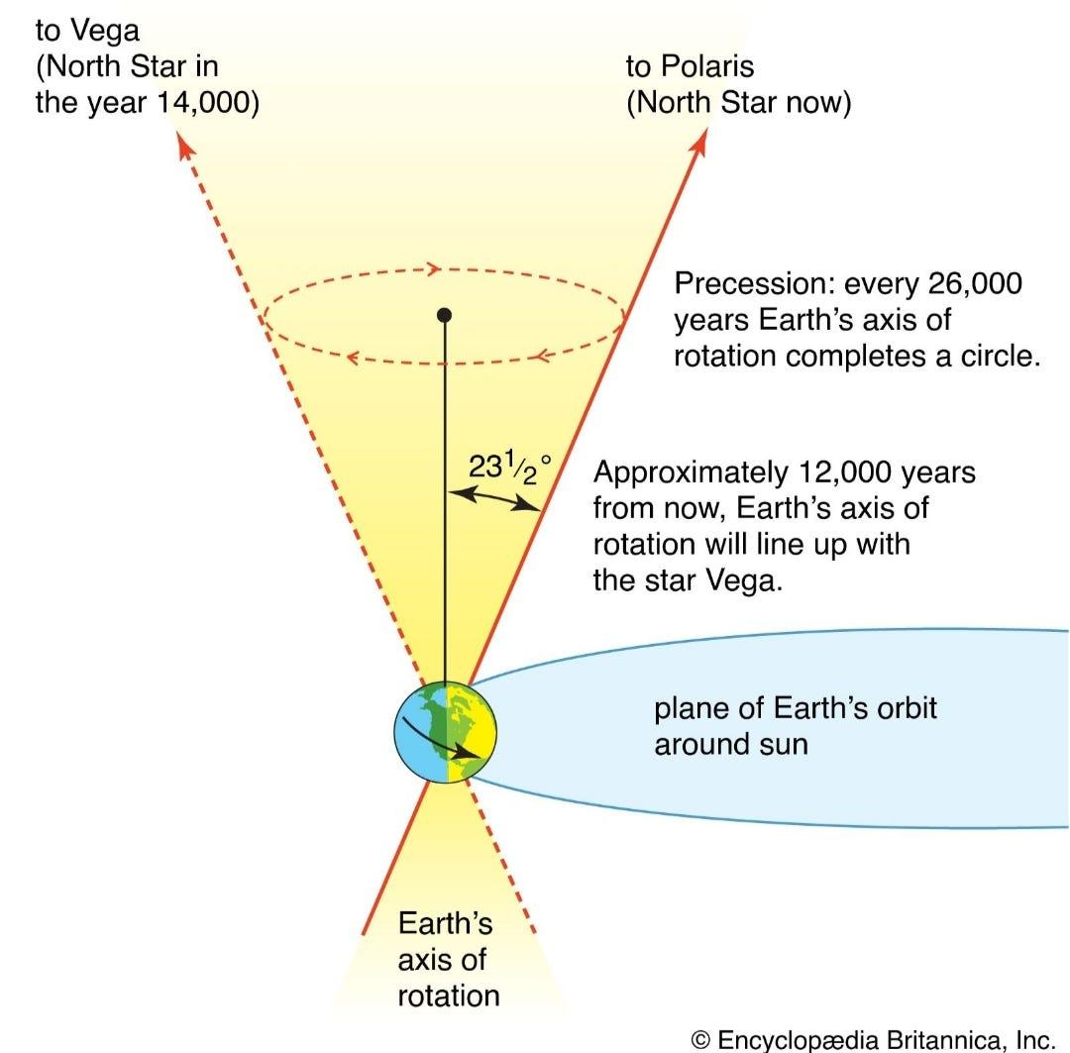
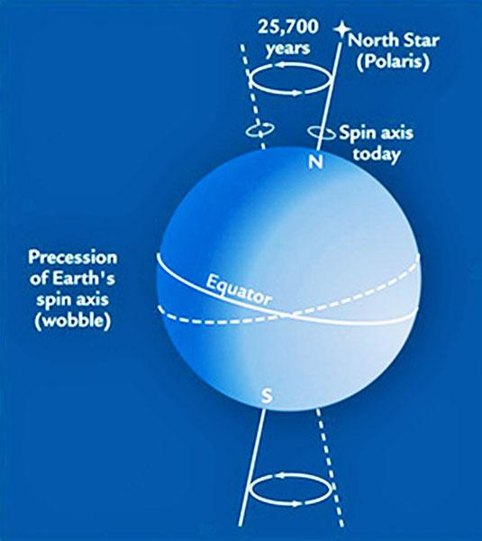
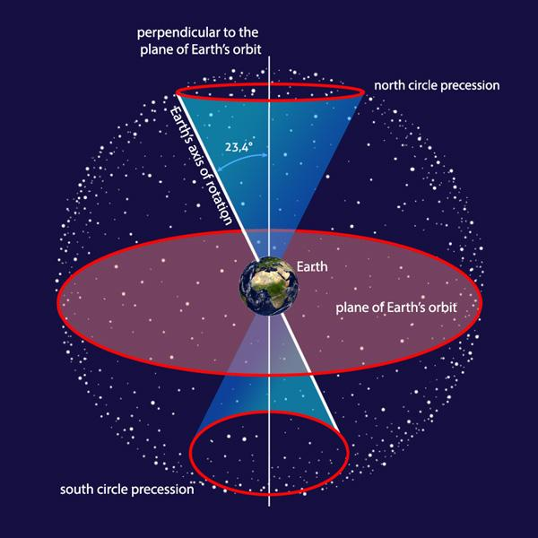
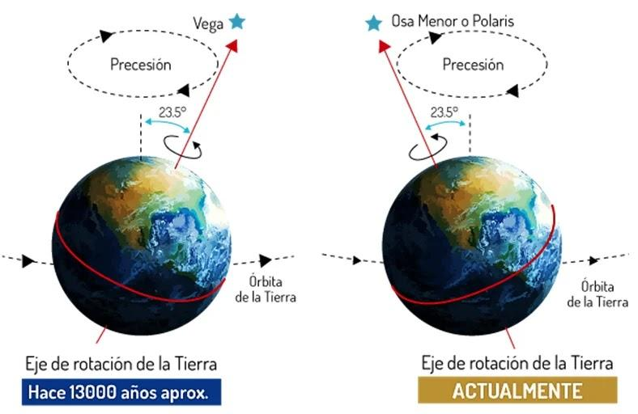
The Earth's axis slowly wobbles like a spinning top.
This motion is called:
- Axial Precession
It completes one full cycle in approximately:
- 25,772 years
Axial precession changes the position of the equinoxes over long periods and causes the tropical year to be slightly shorter than the sidereal year.

Applications
# Source: AI Source: Provided by: [Data Path: Persons Table -> ID Column: 1, Name_En Column: Motasem Essam] -> From: [ChatGPT] on [7/17/2026]
The sidereal year is important in:
- Astronomy
- Celestial mechanics
- Star catalogs
- Orbital calculations
- Space science
- Observational astronomy
It is not normally used for civil calendars.

Relationship to Other Time Units
# Source: AI Source: Provided by: [Data Path: Persons Table -> ID Column: 1, Name_En Column: Motasem Essam] -> From: [ChatGPT] on [7/17/2026]
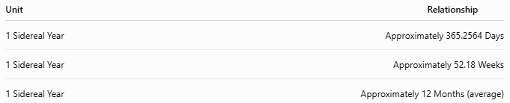
Unit | Relationship
1 Sidereal Year | Approximately 365.2564 Days
1 Sidereal Year | Approximately 52.18 Weeks
1 Sidereal Year | Approximately 12 Months (average)

Sidereal Year vs. Tropical Year
# Source: AI Source: Provided by: [Data Path: Persons Table -> ID Column: 1, Name_En Column: Motasem Essam] -> From: [ChatGPT] on [7/17/2026]
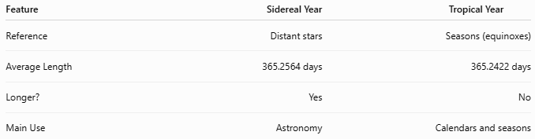
Feature | Sidereal Year | Tropical Year
Reference | Distant stars | Seasons (equinoxes)
Average Length | 365.2564 days | 365.2422 days
Longer? | Yes | No
Main Use | Astronomy | Calendars and seasons

Sidereal Year vs. Calendar Year
# Source: AI Source: Provided by: [Data Path: Persons Table -> ID Column: 1, Name_En Column: Motasem Essam] -> From: [ChatGPT] on [7/17/2026]
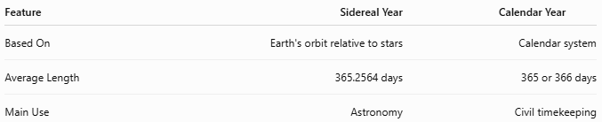
Feature | Sidereal Year | Calendar Year
Based On | Earth's orbit relative to stars | Calendar system
Average Length | 365.2564 days | 365 or 366 days
Main Use | Astronomy | Civil timekeeping

Advantages
# Source: AI Source: Provided by: [Data Path: Persons Table -> ID Column: 1, Name_En Column: Motasem Essam] -> From: [ChatGPT] on [7/17/2026]
Using the sidereal year:
- Provides a stable reference relative to the stars.
- Supports precise astronomical observations.
- Helps calculate planetary positions.
- Is useful in celestial navigation.

Limitations
# Source: AI Source: Provided by: [Data Path: Persons Table -> ID Column: 1, Name_En Column: Motasem Essam] -> From: [ChatGPT] on [7/17/2026]
The sidereal year:
- Does not stay aligned with the seasons.
- Is not suitable for civil calendars.
- Is slightly longer than the seasonal year.

Common Mistakes
# Source: AI Source: Provided by: [Data Path: Persons Table -> ID Column: 1, Name_En Column: Motasem Essam] -> From: [ChatGPT] on [7/17/2026]
- Confusing the Sidereal Year with the Tropical Year.
- Assuming all definitions of a year have the same length.
- Believing the sidereal year determines the seasons (it does not).

Interesting Facts
# Source: AI Source: Provided by: [Data Path: Persons Table -> ID Column: 1, Name_En Column: Motasem Essam] -> From: [ChatGPT] on [7/17/2026]
- The Earth's orbit itself changes very little from year to year, but the Earth's axis slowly precesses, changing the direction it points in space.
- Astronomers often use the sidereal year when studying the positions and motions of stars and planets.

Key Points
# Source: AI Source: Provided by: [Data Path: Persons Table -> ID Column: 1, Name_En Column: Motasem Essam] -> From: [ChatGPT] on [7/17/2026]
Key Points
- A Sidereal Year measures the Earth's orbit relative to the distant stars.
- Average length:
$$365.2564\text{ days}$$
- It is about 20 minutes longer than the Tropical Year.
- The difference is caused by axial precession.
- The sidereal year is primarily used in astronomy, while the tropical year is used for calendars and seasons.

Conclusion
# Source: AI Source: Provided by: [Data Path: Persons Table -> ID Column: 1, Name_En Column: Motasem Essam] -> From: [ChatGPT] on [7/17/2026]
The Sidereal Year is the time required for the Earth to complete one full orbit around the Sun relative to the distant stars, lasting approximately 365.2564 days. Because of the slow precession of the Earth's rotational axis, it is slightly longer than the Tropical Year, which governs the cycle of the seasons. Although the sidereal year is not used for civil calendars, it is essential in astronomy, celestial mechanics, and the precise study of the motions and positions of stars and planets.

